**Discrete Mathematical Structures Tutorial**

**Week 1**

**Portions**

* **Laws of logic**
* **Logical equivalence**

1. Define the following with an example each: (i) Proposition ii) Tautology iii) Contraction iv) Dual of a statement
2. State and Verify Absorption Law.
3. Use the logical equivalences above to show that ¬(p ∨ ¬(p ∧ q)) is a contradiction.
4. Find a simple form for the negation of the proposition “If the sun is shining, then I am going to the ball game.”
5. Determine the truth value of each of the following
6. If 3 + 4 = 12 then 3 + 2 = 6
7. if 4 + 4 = 8 then 5 + 4 = 10
8. If Dr. Radhakrishnan was the first president of India then 3 + 4 = 7.
9. Prove that, for any propositions p, q, r the compound propositions are tautologies
10. [(p ∨ q) → r] ↔ [¬r → ¬(p ∨ q)]
11. [(p∨q) ¬{p∧(¬q∨¬r)}]∨(¬p∧¬q) ∨(¬p∧¬q)
12. Prove the logical equivalence using laws of logic:
13. ¬(p ∨ (¬p ∧ q)) ⇔ ¬p ∧¬q
14. ~[~[(p ∨ q) ∧ r] ∨ ~ q] ⇔ q ∧ r

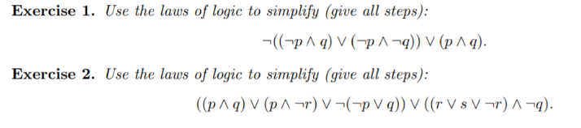

7.



1. Simplify the switching networks:

|  |  |
| --- | --- |
|  |  |
|  | |

1. Negate and simply the following statements:



1. Verify the principle of duality for the logical equivalence: ~(p ∧ q) → (~p ∨ (~p ∨ q)) ⟺ ~p ∨ q.
2. Write down the contrapositive of [p → (q → r)] with
3. only one occurrence of the connective→
4. no occurrence of the connective→